**New Web UI**

The log results, and log detail will remain the same. Need to paginate the log results.

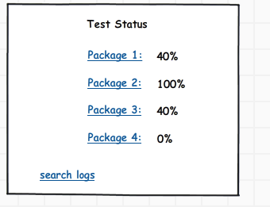

*Figure 1: Initial splash page*

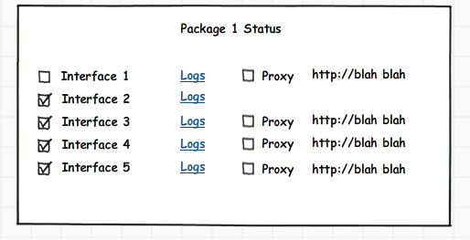

*Figure 2: package drill down*

Logs link will auto select all from logs for specific interface

Proxy option only appears if interface.proxy_flag = 1

Proxy option is checked if proxy_interface record exists

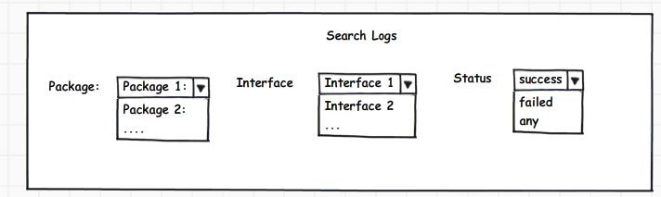

*Figure 3: Log search screen*

Selection of package will change the interface selection.

**Database changes:**

create table package (

id int(11) not null primary key,

name varchar(20)

);

// unique index on name

create unique i_package_name on package(name);

insert into package (id, name) values (1, 'Meter Connect');

insert into package (id, name) values (2, 'OnDemand Read');

insert into package (id, name) values (3, 'Scheduled Read');

insert into package (id, name) values (4, 'Meter Tamper');

insert into package (id, name) values (5, 'Outage Management');

create table interface

id int(11) not null primary key,

name varchar(20),

package_id not null,

proxy_flag int(1) default 0

);

// unique index on name

create unique i_interface_name on interface(name);

alter table interface

add foreign key(package_id) references package(id);

insert into interface(id,name,package_id,proxy_flag)

values (1, 'Disconnect', 1, 1);

alter table EpriLog add (interface_id int(11))

// foreign key for interface_id

Alter table EpriLog

Add foreign key (interface_id) references interface(id);

create table proxy_interface (

id int not null auto_increment primary key,

interface_id int(11),

proxy_url varchar(512)

);

// foreign key interface_id

alter table proxy_interface

add foreign key(interface_id) references interface(id);